Polygonal Dissection

Definition
# Source: AI Source: Provided by: [Data Path: Persons Table -> ID Column: 1, Name_En Column: Motasem Essam] -> From: [ChatGPT] on [7/25/2026]
Polygonal Dissection is a geometric dissection method in which a geometric figure is divided into polygonal pieces—regions bounded entirely by straight line segments. These pieces can be analyzed, rearranged, combined, or compared to form another figure or demonstrate geometric relationships.
The pieces may be triangles, quadrilaterals, pentagons, hexagons, or polygons with more sides. Polygonal dissection is used in area problems, geometric proofs, tiling, construction puzzles, and the study of equivalent figures.

Simple Definition
# Source: AI Source: Provided by: [Data Path: Persons Table -> ID Column: 1, Name_En Column: Motasem Essam] -> From: [ChatGPT] on [7/25/2026]
Polygonal dissection means cutting a geometric figure into smaller polygon-shaped pieces using straight-line cuts.
For example, a hexagon can be divided into four triangles by drawing diagonals from one vertex.
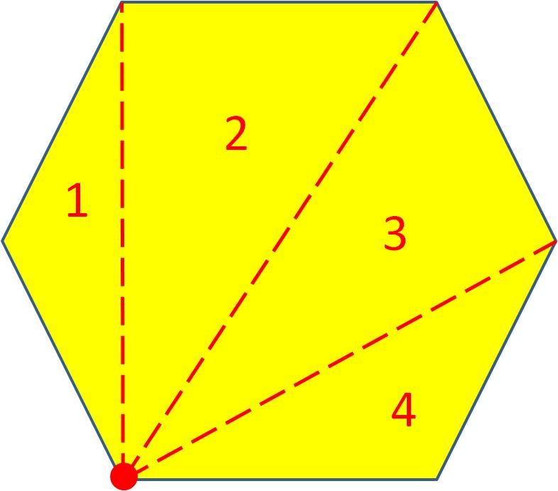

Main Classification
# Source: AI Source: Provided by: [Data Path: Persons Table -> ID Column: 1, Name_En Column: Motasem Essam] -> From: [ChatGPT] on [7/25/2026]
The following is a practical classification of polygonal dissection. These categories are descriptive rather than a universally standardized taxonomy, and some methods can overlap.

1. Triangulation-Based Polygonal Dissection
# Source: AI Source: Provided by: [Data Path: Persons Table -> ID Column: 1, Name_En Column: Motasem Essam] -> From: [ChatGPT] on [7/25/2026]
Divides a polygon into triangles using diagonals or segments.
Example: A convex pentagon divided into three triangles.
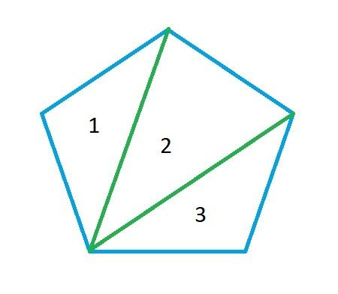
Detailed Explanation of Each Type
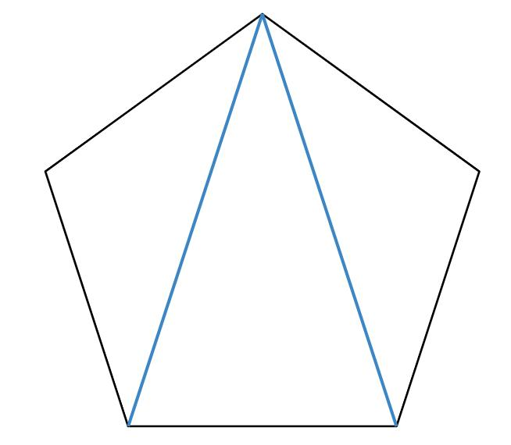
Definition: Dividing a polygon into triangles by drawing non-crossing diagonals or other straight segments inside it.
For a simple polygon with $n$ vertices, a triangulation produces
$$T=n-2$$
triangles.
Example: A convex pentagon has $5$ vertices. Drawing two diagonals from one vertex divides it into
$$T=5-2=3$$
triangles.
Suppose their areas are $8$, $10$, and $12$ square units. Then the pentagon's area is
$$A=8+10+12=\boxed{30}$$
This method is particularly useful for calculating polygon areas and proving polygon area formulas.

2. Quadrilateral-Based Polygonal Dissection
# Source: AI Source: Provided by: [Data Path: Persons Table -> ID Column: 1, Name_En Column: Motasem Essam] -> From: [ChatGPT] on [7/25/2026]
Divides a polygon into quadrilateral pieces.
Example: A polygon partitioned into several trapezoids or other quadrilaterals.
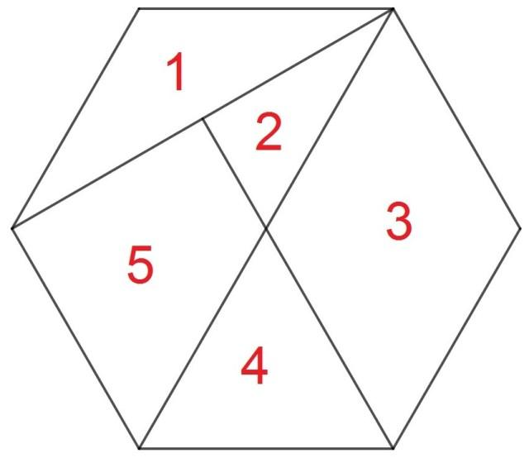
Detailed Explanation of Each Type
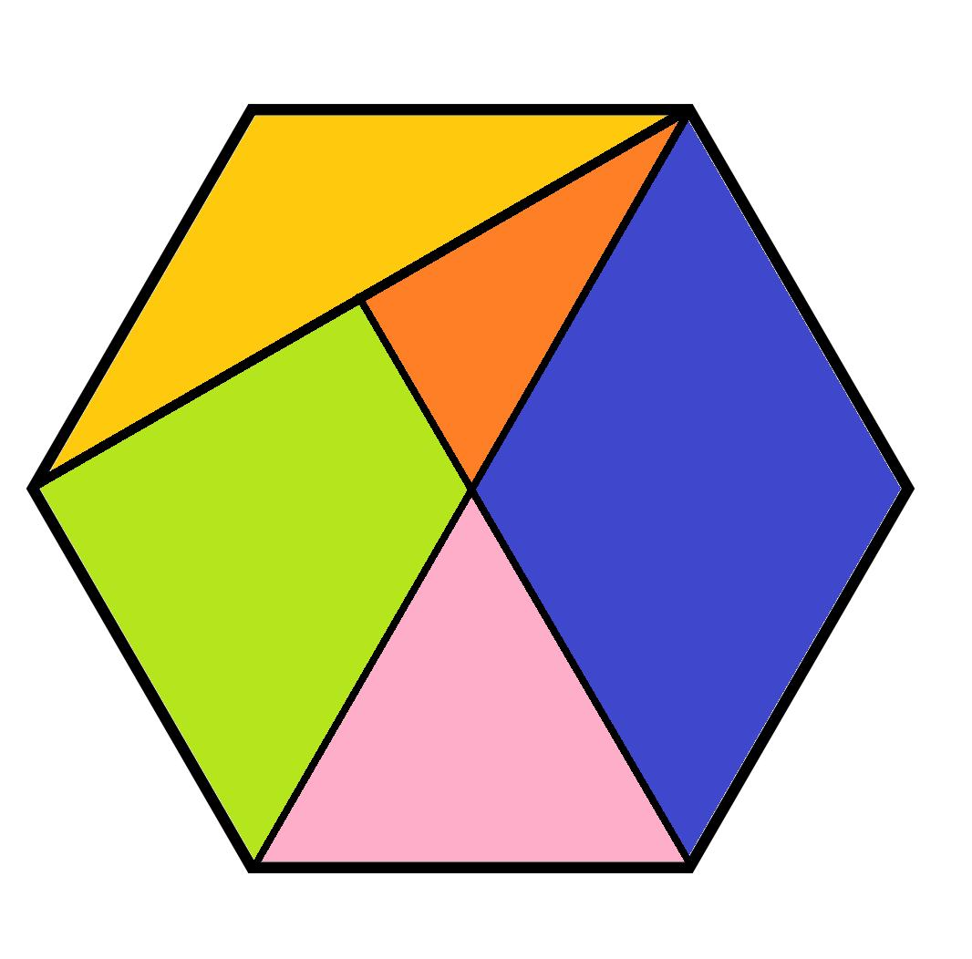
Definition: Dividing a polygon into pieces that each have four sides.
The quadrilaterals may be rectangles, squares, parallelograms, trapezoids, or irregular quadrilaterals.
Example: A $12×6$ rectangle is divided by two vertical cuts into three rectangles of widths $3$, $4$, and $5$.
Their areas are
$$A_{1}=3\left(6\right)=18$$
$$A_{2}=4\left(6\right)=24$$
$$A_{3}=5\left(6\right)=30$$
Therefore,
$$A_{\text{total}}=18+24+30=\boxed{72}$$
Each piece is a quadrilateral, and the pieces reconstruct the original rectangle.

3. Mixed-Polygon Dissection
# Source: AI Source: Provided by: [Data Path: Persons Table -> ID Column: 1, Name_En Column: Motasem Essam] -> From: [ChatGPT] on [7/25/2026]
Uses pieces with different numbers of sides.
Example: A polygon divided into triangles, quadrilaterals, and pentagons.
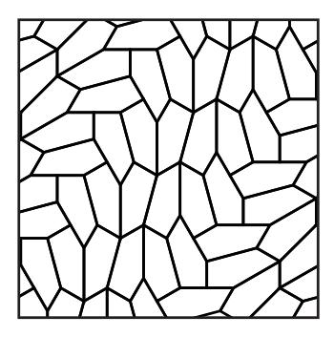
Detailed Explanation of Each Type
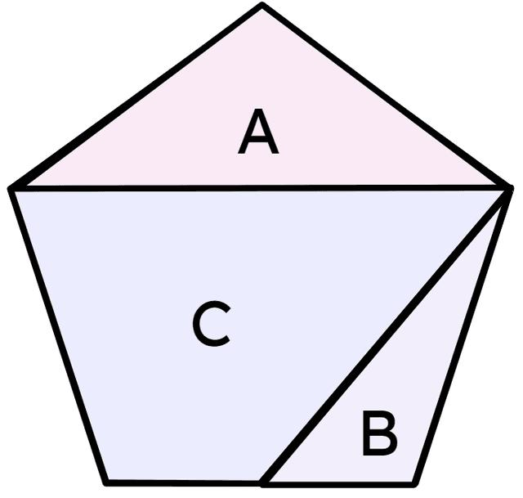
Definition: Dividing a figure into polygonal pieces with different numbers of sides.
Example: A polygon is partitioned into three regions: a triangle, a quadrilateral, and a pentagon. Suppose their areas are $6$, $14$, and $20$ square units.
Then
$$A_{\text{total}}=6+14+20=\boxed{40}$$
The number of sides of each piece does not have to be the same. The essential requirement is that the pieces form a valid partition of the original figure.

4. Center-Based Polygonal Dissection
# Source: AI Source: Provided by: [Data Path: Persons Table -> ID Column: 1, Name_En Column: Motasem Essam] -> From: [ChatGPT] on [7/25/2026]
Uses segments from a central point to boundary vertices or points to form polygonal pieces.
Example: A regular hexagon divided into six congruent triangles by connecting its center to every vertex.
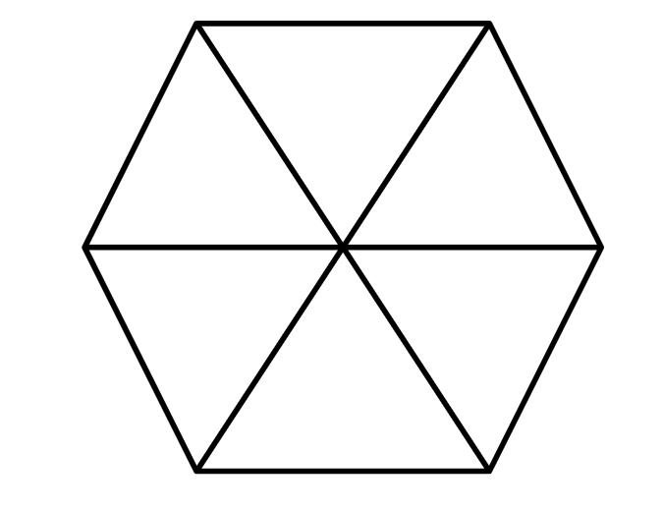
Detailed Explanation of Each Type
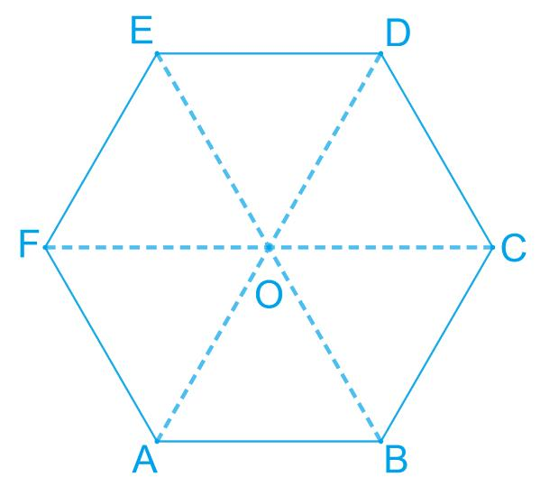
Definition: Dividing a polygon by connecting a central point to selected boundary points, often its vertices.
Example: A regular hexagon with side length $4$ is divided by connecting its center to all six vertices. This creates six congruent equilateral triangles.
The area of one equilateral triangle is
$$A_{1}=\frac{\sqrt{3}}{4}{\left(4\right)}^{2}=4\sqrt{3}$$
The total area is
$$A=6\left(4\sqrt{3}\right)=\boxed{24\sqrt{3}}$$
This construction works especially naturally for regular polygons, whose center is equidistant from every vertex.

5. Diagonal-Based Polygonal Dissection
# Source: AI Source: Provided by: [Data Path: Persons Table -> ID Column: 1, Name_En Column: Motasem Essam] -> From: [ChatGPT] on [7/25/2026]
Uses diagonals between vertices to divide a polygon into smaller polygons.
Example: Drawing two suitable diagonals in a convex hexagon to create smaller polygonal regions.
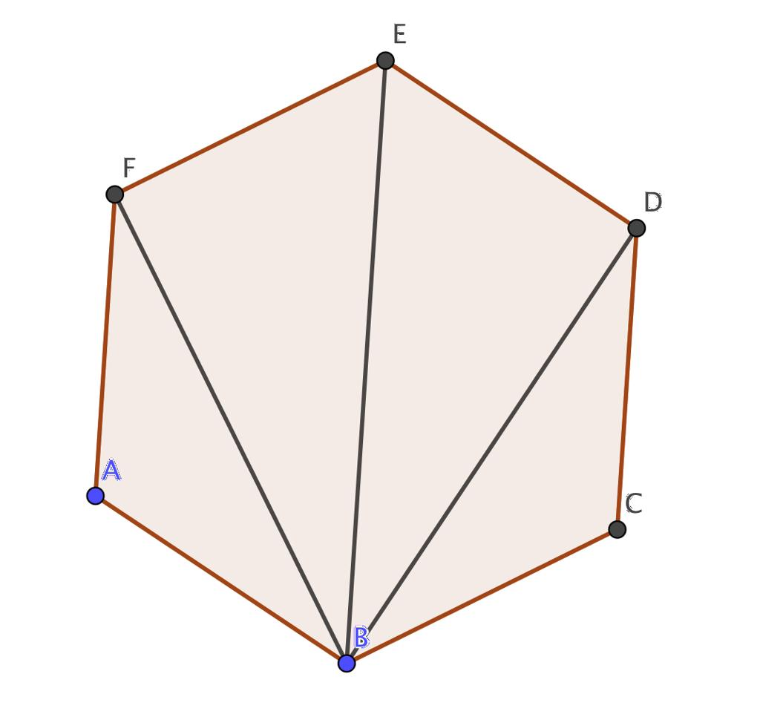
Detailed Explanation of Each Type
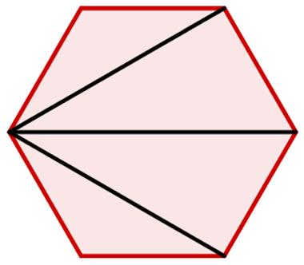
Definition: Using diagonals—segments joining non-adjacent vertices—to subdivide a polygon into smaller polygons.
Example: Draw two non-crossing diagonals from one vertex of a convex hexagon. These diagonals divide the hexagon into three regions. Depending on the chosen diagonals, the regions may be triangles or larger polygons.
If the three regions have areas $A_{1}$, $A_{2}$, and $A_{3}$, then
$$A_{\text{hexagon}}=A_{1}+A_{2}+A_{3}$$
A diagonal-based dissection must use diagonals that lie inside the polygon and do not cross one another except at shared endpoints.

6. Concave-Polygon Dissection
# Source: AI Source: Provided by: [Data Path: Persons Table -> ID Column: 1, Name_En Column: Motasem Essam] -> From: [ChatGPT] on [7/25/2026]
Divides a concave polygon, which has at least one interior angle greater than ${180}^{∘}$.
Example: An L-shaped polygon split into rectangles and triangles.
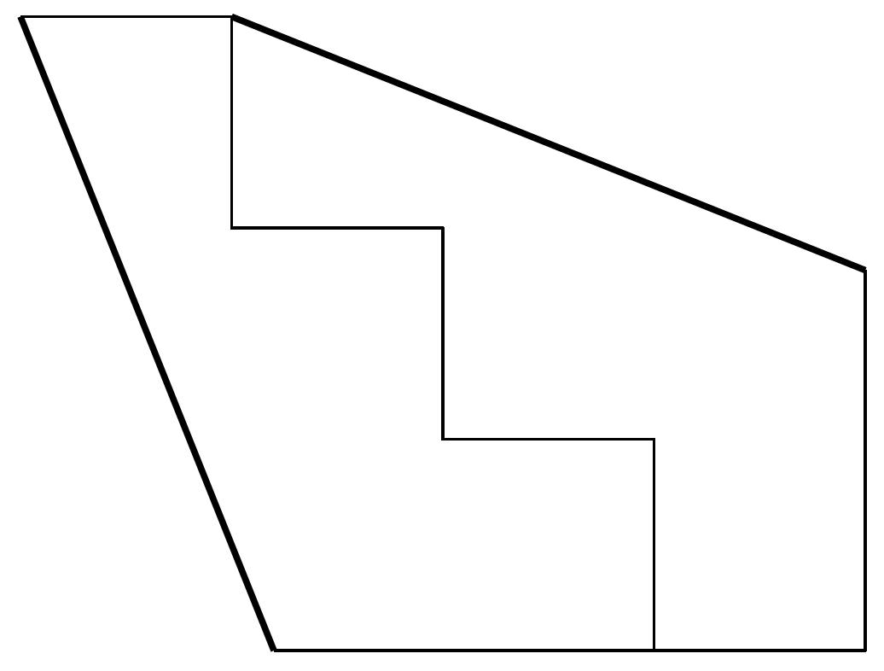
Detailed Explanation of Each Type
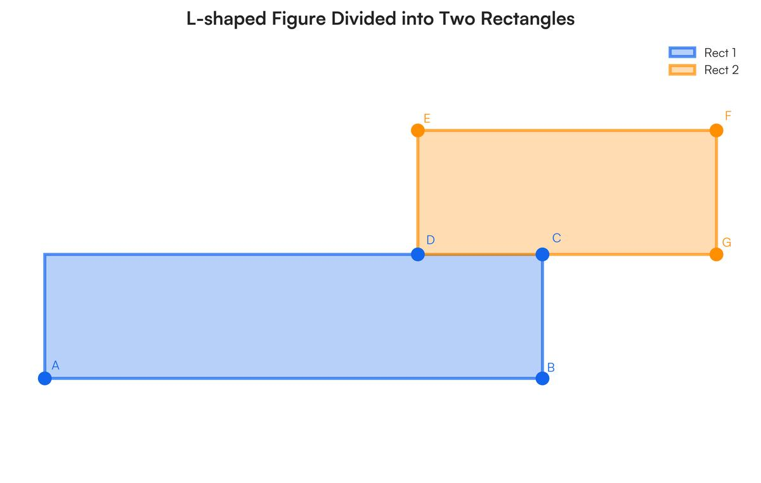
Definition: Dividing a concave polygon into smaller polygons. A concave polygon has at least one interior angle greater than ${180}^{∘}$.
Example: An L-shaped figure is made from a $10×8$ rectangle with a $4×5$ rectangle removed from a corner.
The original rectangle's area is
$$A_{1}=10\left(8\right)=80$$
The removed region's area is
$$A_{2}=4\left(5\right)=20$$
Therefore, the L-shaped figure has area
$$A=80-20=\boxed{60}$$
The same figure can be partitioned into two rectangles, with areas $6×8=48$ and $4×3=12$, giving $48+12=60$.

7. Equal-Area Polygonal Dissection
# Source: AI Source: Provided by: [Data Path: Persons Table -> ID Column: 1, Name_En Column: Motasem Essam] -> From: [ChatGPT] on [7/25/2026]
Divides a figure into polygonal pieces with equal areas, although their shapes may differ.
Example: A polygon divided into four regions, each with area \(12\) square units.
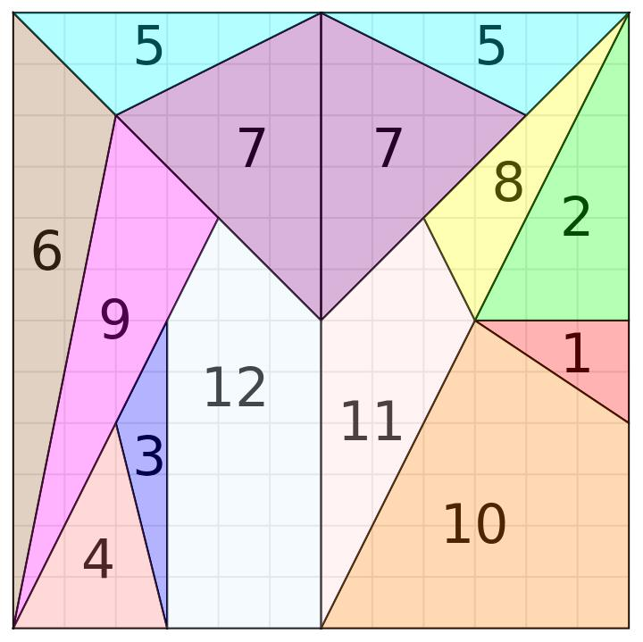
Detailed Explanation of Each Type
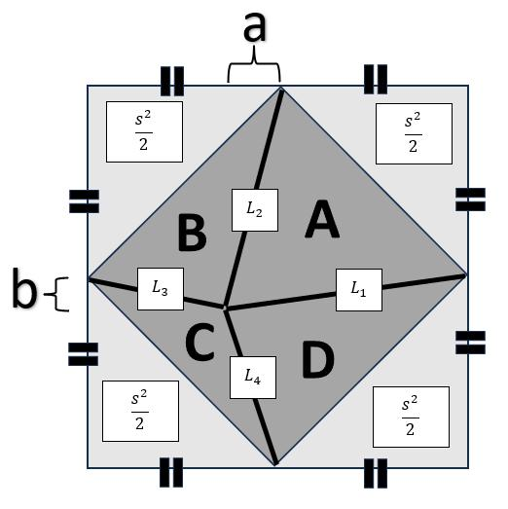
Definition: Dividing a figure into polygonal pieces that have equal areas. The pieces may or may not be congruent.
Example: A polygon with total area $48$ square units is divided into four polygonal regions of equal area.
$$A_{\text{piece}}=\frac{48}{4}=\boxed{12}$$
Each piece must have area $12$ square units, even if their side lengths and shapes differ.
Important distinction: Equal area does not imply equal shape, equal perimeter, or congruence.

8. Rearrangement-Based Polygonal Dissection
# Source: AI Source: Provided by: [Data Path: Persons Table -> ID Column: 1, Name_En Column: Motasem Essam] -> From: [ChatGPT] on [7/25/2026]
Cuts a figure into polygonal pieces that can be rearranged to form another figure.
Example: Polygonal pieces of a square rearranged to form a rectangle of equal area.
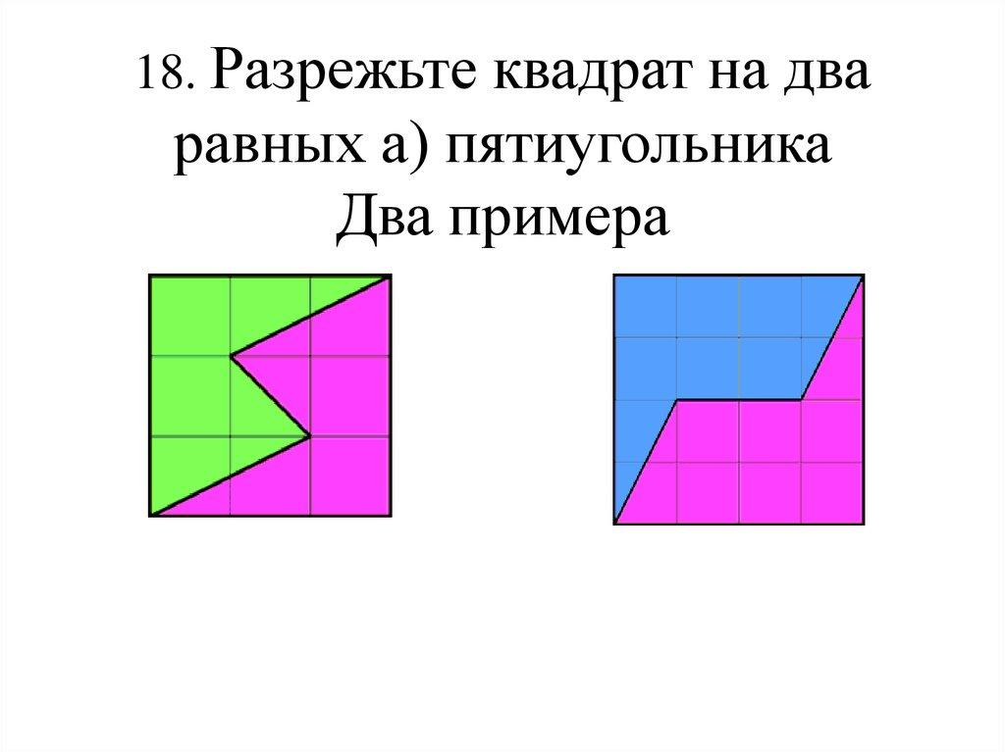
Detailed Explanation of Each Type
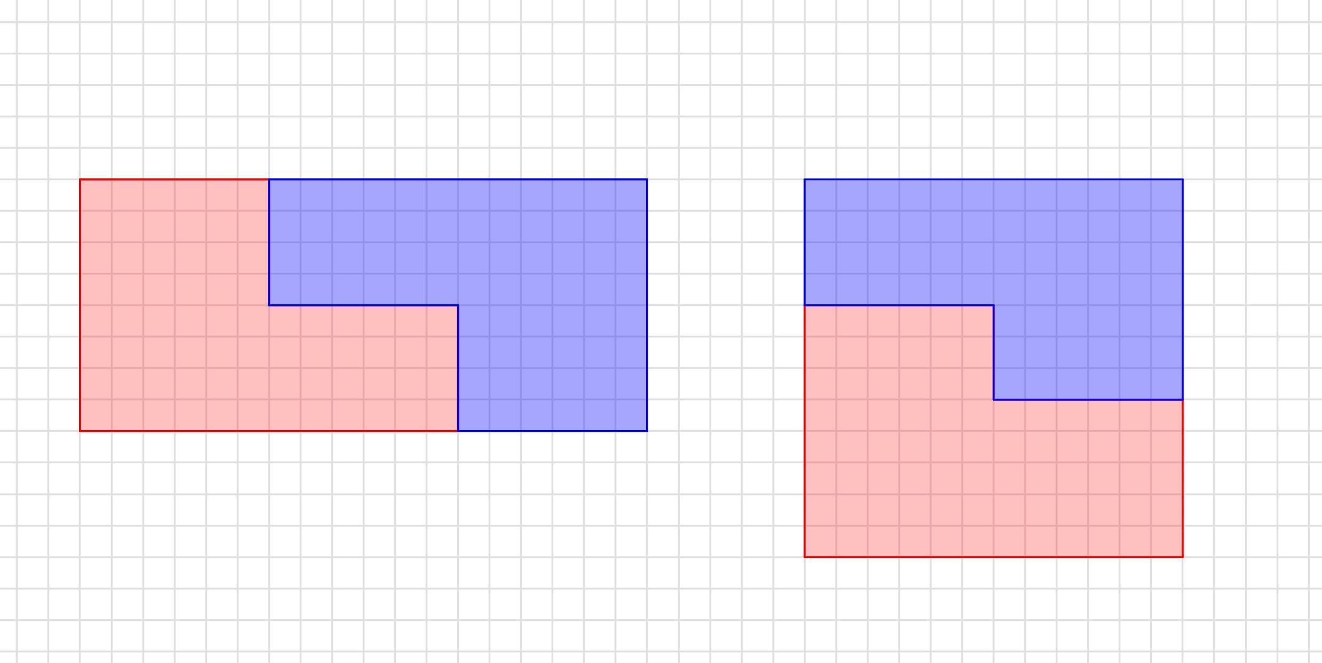
Definition: Dividing a figure into polygonal pieces and rearranging them to construct a different figure without changing the pieces themselves.
Example: Divide a $4×4$ square into two $4×2$ rectangles. Arrange the two rectangles side by side along their $4$-unit sides to form an $8×2$ rectangle.
Original area:
$$A_{1}=4\left(4\right)=16$$
Rearranged area:
$$A_{2}=8\left(2\right)=16$$
Thus,
$$\boxed{A_{1}=A_{2}}$$
This is a simple example of an area-preserving polygonal dissection.

9. Multiple-Segment Polygonal Dissection
# Source: AI Source: Provided by: [Data Path: Persons Table -> ID Column: 1, Name_En Column: Motasem Essam] -> From: [ChatGPT] on [7/25/2026]
Uses several internal segments to create many polygonal regions.
Example: A polygon divided by multiple diagonals and interior segments.
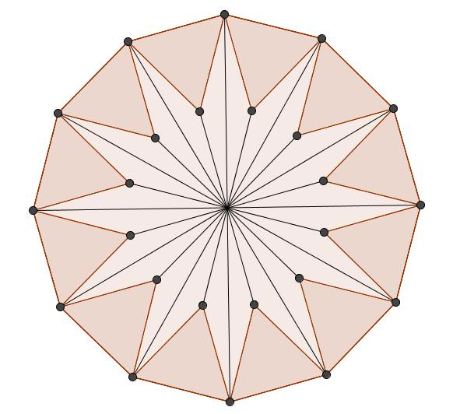
Detailed Explanation of Each Type
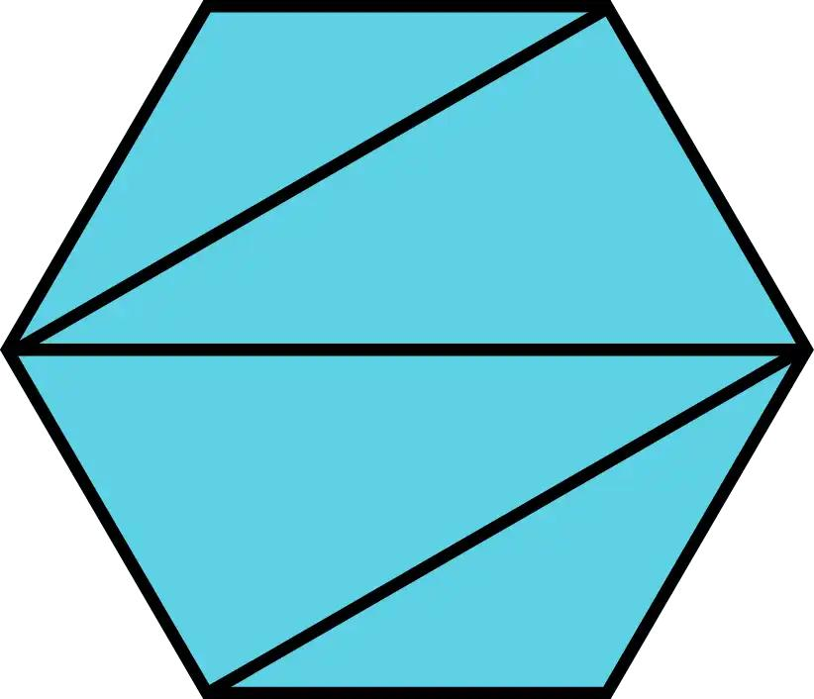
Definition: Using several internal segments to create multiple polygonal pieces in one figure.
Example: A convex hexagon is triangulated by drawing three diagonals from one vertex. This produces four triangles because
$$T=6-2=4$$
If the four triangle areas are $7$, $9$, $11$, and $13$ square units, then
$$A=7+9+11+13=\boxed{40}$$
The number and shape of regions depend on the placement and number of internal segments.

10. Multi-Stage Polygonal Dissection
# Source: AI Source: Provided by: [Data Path: Persons Table -> ID Column: 1, Name_En Column: Motasem Essam] -> From: [ChatGPT] on [7/25/2026]
Divides a figure into polygons and then subdivides selected pieces further.
Example: A square first divided into quadrilaterals, with one quadrilateral then split into triangles.
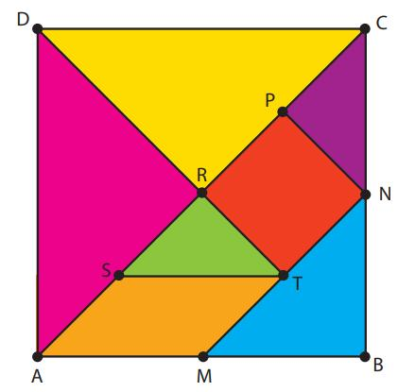
Detailed Explanation of Each Type
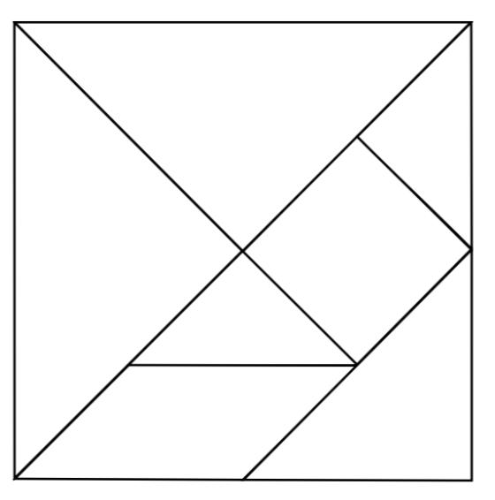
Definition: Dividing a figure into polygonal pieces and then subdividing one or more of those pieces in subsequent stages.
Example: A square has area $64$ square units. First, divide it into four equal squares, each of area $16$. Then divide one of those squares along a diagonal into two triangles.
The final pieces consist of:
- Three squares, each of area $16$.
- Two triangles, each of area $8$.
The total area is
$$A=3\left(16\right)+2\left(8\right)=\boxed{64}$$
The second-stage subdivision changes the number and types of pieces but does not change the total area.

Key Formulas for Polygonal Dissection
# Source: AI Source: Provided by: [Data Path: Persons Table -> ID Column: 1, Name_En Column: Motasem Essam] -> From: [ChatGPT] on [7/25/2026]
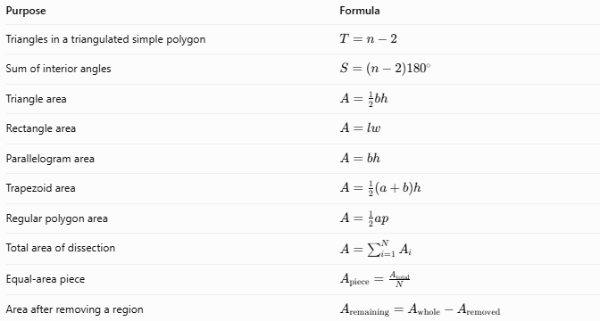
Purpose | Formula
Triangles in a triangulated simple polygon | $$T=n-2$$
Sum of interior angles | $$S=\left(n-2\right){180}^{∘}$$
Triangle area | $$A=\frac{1}{2}bh$$
Rectangle area | $$A=lw$$
Parallelogram area | $$A=bh$$
Trapezoid area | $$A=\frac{1}{2}\left(a+b\right)h$$
Regular polygon area | $$A=\frac{1}{2}ap$$
Total area of dissection | $$A=\sum_{i=1}^{N}{A_{i}}$$
Equal-area piece | $$A_{\text{piece}}=\frac{A_{\text{total}}}{N}$$
Area after removing a region | $$A_{\text{remaining}}=A_{\text{whole}}-A_{\text{removed}}$$
Here:
- $n$ is the number of vertices of a simple polygon.
- $T$ is the number of triangles in a triangulation.
- $a$ and $b$ in the trapezoid formula are the parallel-side lengths.
- $a$ in the regular polygon formula is the apothem, and $p$ is the perimeter.
- $N$ is the number of pieces.
The formula $T=n-2$ applies to a triangulation of a simple polygon, including concave polygons, using valid non-crossing diagonals.

Comparison with Other Dissection Methods
# Source: AI Source: Provided by: [Data Path: Persons Table -> ID Column: 1, Name_En Column: Motasem Essam] -> From: [ChatGPT] on [7/25/2026]
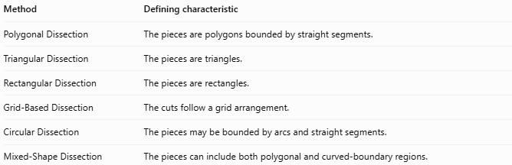
Method | Defining characteristic
Polygonal Dissection | The pieces are polygons bounded by straight segments.
Triangular Dissection | The pieces are triangles.
Rectangular Dissection | The pieces are rectangles.
Grid-Based Dissection | The cuts follow a grid arrangement.
Circular Dissection | The pieces may be bounded by arcs and straight segments.
Mixed-Shape Dissection | The pieces can include both polygonal and curved-boundary regions.
These categories are not mutually exclusive. For example, a grid-based dissection of a rectangle into smaller rectangles is also a polygonal dissection.

Classification Summary
# Source: AI Source: Provided by: [Data Path: Persons Table -> ID Column: 1, Name_En Column: Motasem Essam] -> From: [ChatGPT] on [7/25/2026]
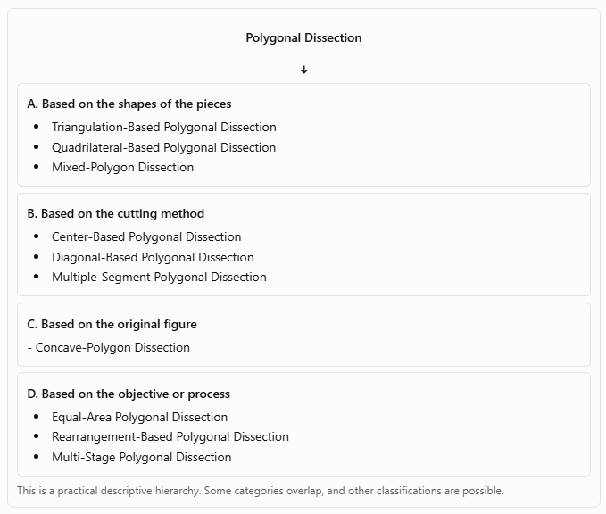
Polygonal Dissection
A. Based on the shapes of the pieces
- Triangulation-Based Polygonal Dissection
- Quadrilateral-Based Polygonal Dissection
- Mixed-Polygon Dissection
B. Based on the cutting method
- Center-Based Polygonal Dissection
- Diagonal-Based Polygonal Dissection
- Multiple-Segment Polygonal Dissection
C. Based on the original figure
- Concave-Polygon Dissection
D. Based on the objective or process
- Equal-Area Polygonal Dissection
- Rearrangement-Based Polygonal Dissection
- Multi-Stage Polygonal Dissection
This is a practical descriptive hierarchy. Some categories overlap, and other classifications are possible.

Key Points
# Source: AI Source: Provided by: [Data Path: Persons Table -> ID Column: 1, Name_En Column: Motasem Essam] -> From: [ChatGPT] on [7/25/2026]
- Polygonal dissection uses straight-line boundaries to create polygonal pieces.
- Triangulation is a particularly important case because every simple polygon can be divided into triangles.
- Polygonal pieces can have equal or unequal areas and may be congruent or noncongruent.
- Rearrangement-based dissection can demonstrate area equivalence between different figures.
- Concave polygons can also be dissected into simpler polygons.
- A valid dissection covers the original figure completely, without gaps or overlapping interiors.
- The sum of the areas of all pieces equals the original area.

Conclusion
# Source: AI Source: Provided by: [Data Path: Persons Table -> ID Column: 1, Name_En Column: Motasem Essam] -> From: [ChatGPT] on [7/25/2026]
Polygonal Dissection is a broad geometric method for dividing figures into smaller polygonal regions using straight segments. It includes triangulation, quadrilateral-based partitioning, mixed-polygon partitioning, diagonal-based cuts, equal-area division, and rearrangement techniques.
Its main mathematical principle is area preservation: the pieces collectively retain the area of the original figure. This makes polygonal dissection useful for calculating areas, proving geometric results, solving puzzles, and understanding how geometric figures can be decomposed and reconstructed.

